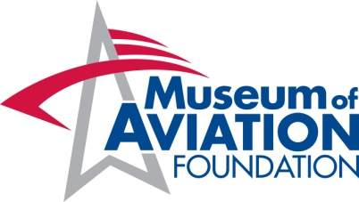

Altitudes Junior Volunteer Application

Name: _____________________________________________________

Address: ___________________________________________________

Telephone number: Home: _________________Cell: ________________

Emergency contact(s) and telephone number(s):

___________________________________________________________

___________________________________________________________

E-mail Address: ______________________________________________

Educational Institution: _________________________________________

Year: ____ Freshman

____ Sophomore

____ Junior

____ Senior

____ Other: ____________________________________________

Area(s) of Interest at the Museum of Aviation: ___________________________________________________________
___________________________________________________________
___________________________________________________________

Altitudes Junior Volunteer Application

______________________ has my permission to participate as a Junior
(Name of Student)

Volunteer with the National STEM Academy’s Altitudes Volunteer Program

at the Museum of Aviation, 1942 Heritage Blvd., Warner Robins, GA.

______________________
(Parent/Guardian Signature)

______________________
(Student Signature)

______________________
(Date)

